sdg-autotest — User Guide
This is the user-facing walkthrough of the five pages in the sdg-autotest UI. Each section follows the same shape: what the page is for, common tasks with step-by-step recipes, and a control reference that explains every visible field and button.
If you are looking at the app for the first time, open the Probe Runner tab — it is the simplest entry point and exercises the full pipeline end to end.

Quick glossary
A few terms appear on every page. Skim once, then come back as needed.
Term | Meaning
Iter | One end-to-end risk-eval call. A run consists of N iters against the same cell.
Frozen retrieval | Pull evidence chunks once, then re-use the exact same set across many iters. Removes retrieval randomness so any difference between iters is purely from the LLM.
Drift | When the same prompt + same evidence produces different verdicts across iters. Lower drift = more deterministic prompt.
SME label / ground truth | An expert-confirmed correct verdict for a cell. Used to score the model's output.
Variant (A / B / C) | A prompt + tunables bundle in the Prompt Lab. Variants are compared head-to-head on the same evidence.

1. Probe Runner

What it's for
Run the live risk-eval pipeline against a chosen ESN + issue + component, N times, and watch the verdicts as they come in. Use this when you want to answer one of these questions:
- "Is the assistant giving a consistent answer on this cell?"
- "What does the assistant currently say for this unit?"
- "Did the prompt change I just deployed actually move the needle?"
The page streams results live as each iter finishes, and persists every run so you can compare today's behavior to last week's.

Common tasks
Task A — Probe a single ESN / issue / component
- Fill in ESN, Issue name, and Component (case- and punctuation-sensitive — they must match the heatmap exactly).
- Set Iters to how many runs you want (1 for a smoke test, 16+ for a determinism check).
- Optional: change Persona (RE is the default), pick a specific Model, or give the run a Name so you can find it later.
- Leave Bust cache on so each iter is a fresh call.
- Click Run.
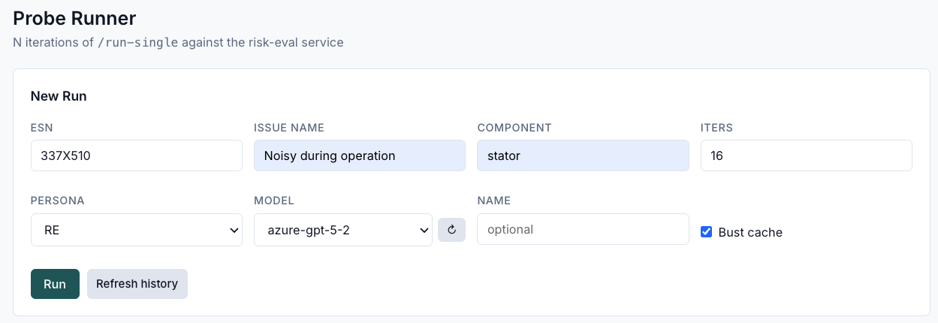
The Current Run card shows iters appearing as they complete: distribution bars at the top, individual verdicts below. The Event log (collapsed by default) shows raw progress events if you want a detailed trace.
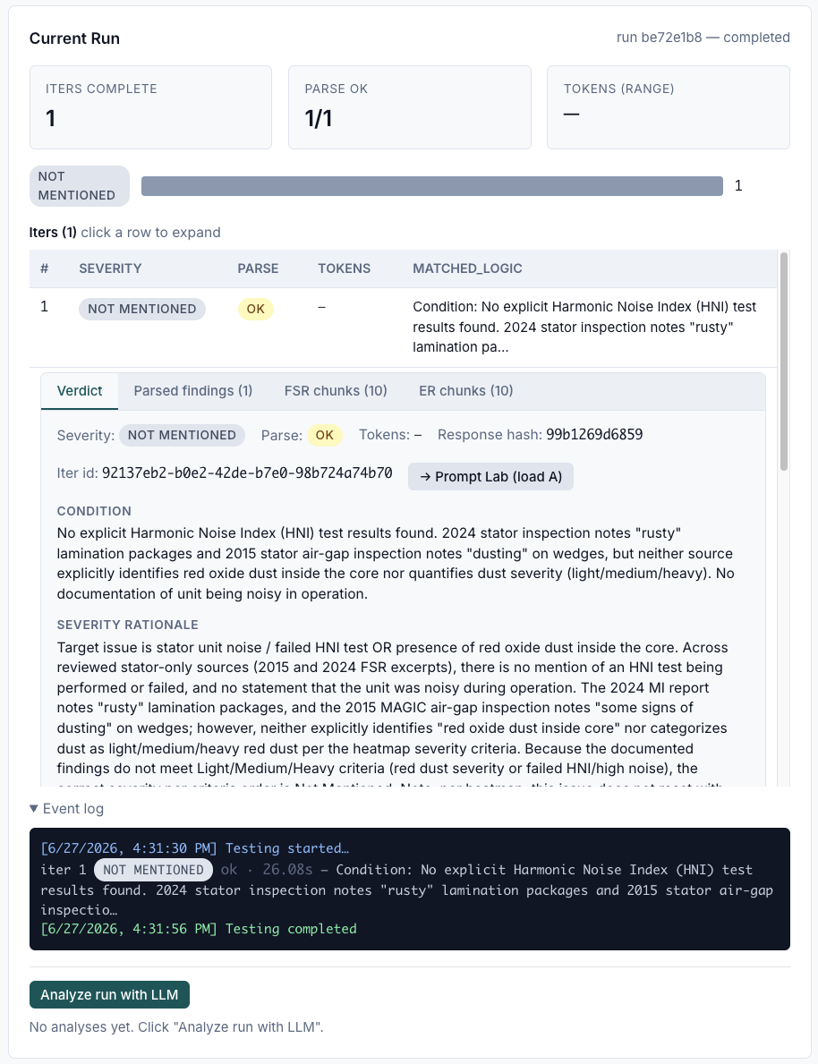

Task B — Look up the SME label for the cell before you run
As soon as you type into the ESN / Issue / Component fields, the Ground Truth Reference card auto-fills with any SME labels that match. This tells you the expected verdict before the run completes, so you can spot deviations immediately.
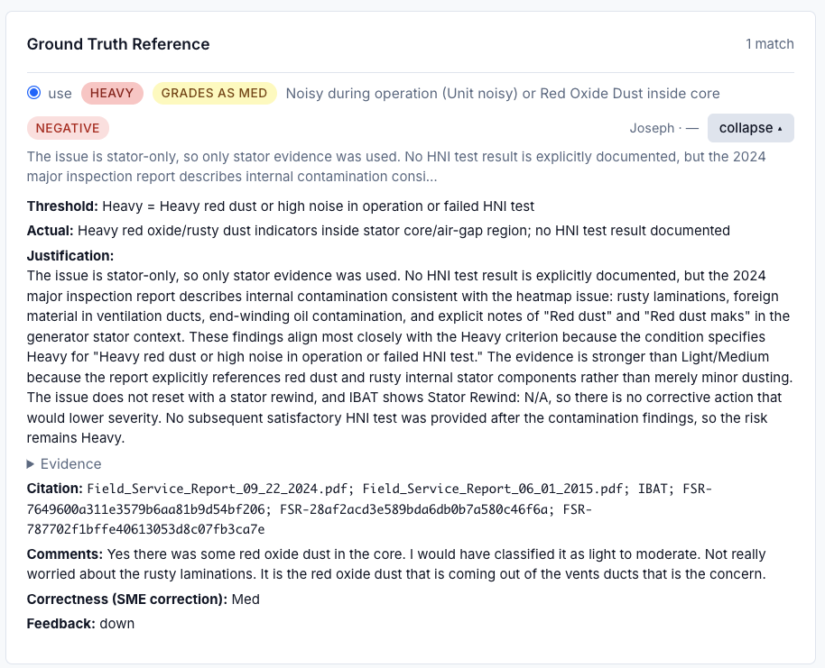

Task C — Compare two runs
- Click Compare two… in the Recent Runs card.
- Pick the two runs from the Run A and Run B dropdowns.
- Click Compare.
You get side-by-side severity distributions plus FSR/ER chunk similarity (Jaccard). High Jaccard with different verdicts means the prompts differ; low Jaccard means retrieval itself changed.
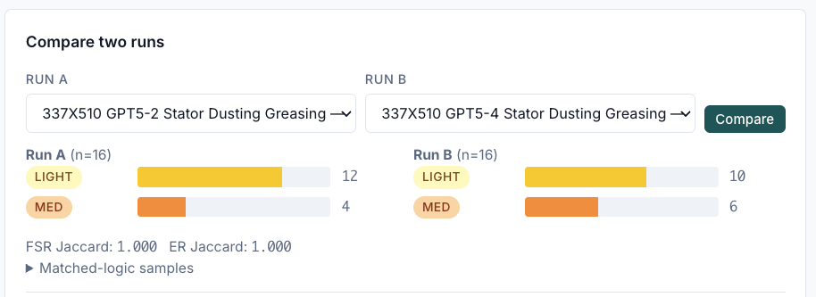

Task D — Get an LLM read on what went wrong
After a run completes, an Analyze run with LLM button appears. Click it to have a model read the entire run (every iter's verdict, matched logic, and prompts) and produce a structured diagnosis: which iters drifted, what the failure pattern looks like, and prompt-level suggestions. Comparison views have their own Analyze comparison with LLM button that diagnoses the two runs together.
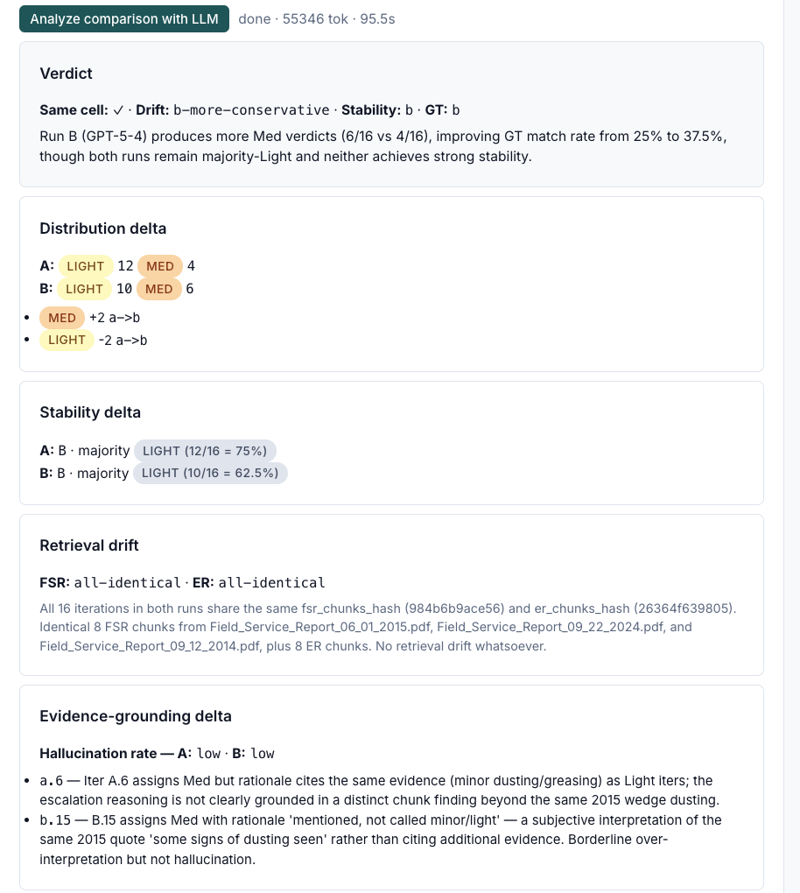

Control reference
Control | What it does
ESN | Generator unit identifier. Must match a row in the heatmap.
Issue name | Heatmap issue text, e.g. Vibration / Rotor. Case-sensitive.
Component | Component the issue scores against, e.g. stator.
Iters | How many times to call the pipeline (1–64). Use ≥ 16 for determinism checks.
Persona | RE (default) or SME. Changes the prompt persona block.
Model | Which LLM to use. Leave as (default) to use whatever the service is configured for; click ↻ to re-fetch the model list.
Name | Optional label that shows up in the run list. Useful for tagging experiments.
Bust cache | When on, each iter appends a unique tag to its prompt so the gateway cannot return a cached response. Keep on for determinism work.
Run | Starts the run. The page streams events live; no need to refresh.
Refresh history | Re-pulls the Recent Runs list.
Current Run → distribution | Bar chart of verdicts so far. Updates live.
Current Run → iters | One row per iter showing severity badge and parse status.
Event log | Collapsed by default. Raw started / iter_complete / iter_error / completed events.
Analyze run with LLM | Asks an analyzer model to diagnose this run's verdicts against SME ground truth (if present).
Recent Runs | Last N runs across the system, newest first. Click a run to load it into the panel.
Compare two… | Opens the comparison panel for A-vs-B diffing.

Reading the results
- All iters same verdict, parse_ok = true → prompt is determinate on this cell.
- Verdicts split across bands → either the evidence is genuinely ambiguous or the prompt has degrees of freedom the model is exercising stochastically.
- parse_ok = false → the model returned something the parser could not read as a verdict. Open the iter row to see the raw response.

2. Prompt Lab — A/B/C

What it's for
Test prompt changes against the same evidence corpus without touching the production risk-eval service. The lab freezes retrieval once for the chosen cell, then replays the LLM call with whatever prompts you put in slots A, B, (and C if you add it). Use it to:
- A/B test a prompt change before shipping.
- Compare an old prompt vs a new prompt on a specific failure case.
- Iterate on a prompt rapidly without re-running retrieval each time.

Common tasks
Task A — Compare two prompt variants on the same evidence
- In Setup, set ESN / Issue name / Component / Iters per variant. Iters of 8–16 give you a determinism read; iters of 1–4 are fine for a quick smoke.
- In Variant A, paste a System prompt and a User prompt template. Optionally set per-variant Model / Temperature / Reasoning effort / Top-k FSR / Top-k ER. Leave any tunable blank to inherit the default.
- Do the same in Variant B.
- Click Run comparison.
Once the run completes, Results appears at the bottom — two columns side by side, one per variant, with the verdict distribution and each iter's matched logic.
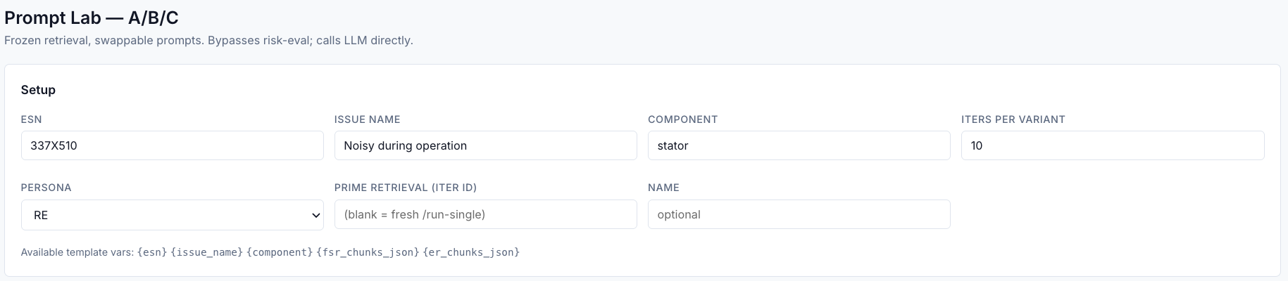

Task B — Load the prompts that risk-eval actually sent for a specific iter
If a Probe Runner iter produced an interesting result and you want to start with the exact prompts the service used:
- Run a Probe Runner iter first; copy the iter's UUID from the iter row.
- In the lab, paste it into Load variant A from a Probe Runner iter and click Load into A (verbatim). This pulls the literal system + user prompts, switches Variant A to verbatim template mode (no template substitution), and pre-fills it.
- Use the per-variant Copy to B / Copy to C buttons (on each variant card) to clone A's content into another slot, then edit there.
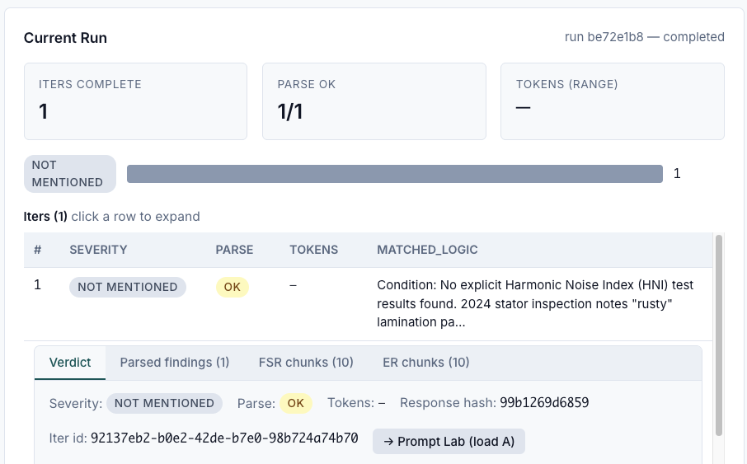

Task C — Save a prompt for reuse
Each variant card has a 💾 Save… button. Clicking it opens a small dialog asking for a name (e.g. gating-method-v2). Saving is append-only — re-saving with the same name creates v2, v3, etc., and the old versions are never overwritten.
The Load dropdown next to the save button lists every saved variant in the library. Pick one to populate this slot with that saved prompt + tunables. The dropdown resets after each load so you can stack a few loads in a row.
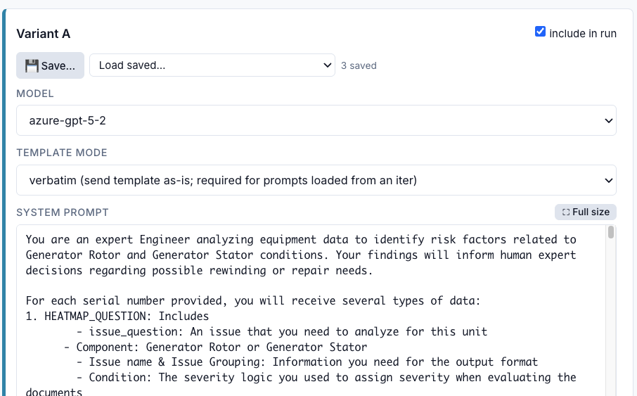

Task D — Promote a lab run to a Test Report
When a lab run is complete, the Results card has a Create Test Report button. Click it to freeze the whole run (all variants, all iters, raw responses, retrieval, ground-truth match) into the Reports tab. The button also reveals a Download link that gives you the same content as a single self-describing JSON file you can share by email or attach to a ticket.
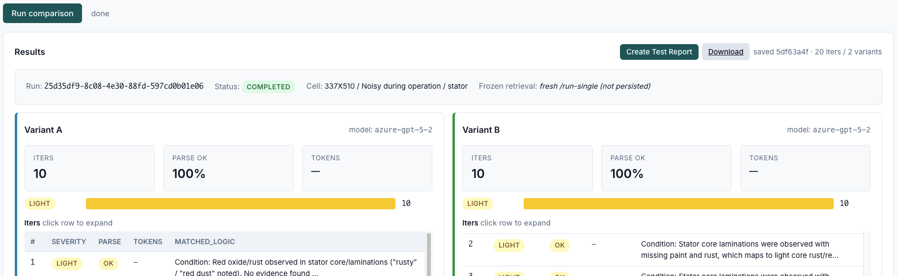

Control reference — Setup
Control | What it does
ESN / Issue name / Component | The cell to evaluate. Same conventions as Probe Runner.
Iters per variant | Calls per variant (1–32). Each variant gets the same number.
Persona | RE or SME.
Prime retrieval (iter id) | Optional. Paste an existing iter's UUID to reuse its retrieval set instead of running a fresh retrieval.
Name | Optional label that shows up in the run list.
Template variables (display only) | Reminder that user prompts can reference {esn}, {issue_name}, {component}, {fsr_chunks_json}, {er_chunks_json}.

Control reference — Variant card
Control | What it does
Include checkbox | Skip this variant on the next run. Use to run A-vs-C without changing B.
System prompt | The system message. Click the field to open a full-screen editor with char count.
User prompt template | The user message. May contain {...} placeholders unless template mode is verbatim.
Template mode | format substitutes {esn} etc.; verbatim sends the prompt exactly as written (use when the prompt contains literal { } braces you don't want substituted).
Model | Override the model for this variant only. Blank = inherit.
Top-k FSR / Top-k ER | Override how many FSR/ER chunks to expose. Blank = inherit.
Temperature | Override sampling temperature. Blank = inherit. Some models ignore this.
Reasoning effort | For reasoning models (o1/o3/GPT-5 family): low / medium / high. Blank = inherit.
💾 Save… | Saves this variant (prompts + tunables) as a named version to the library.
Load… dropdown | Loads a saved variant into this slot.
Copy to A/B/C | Clones this variant into another slot for incremental editing.

Control reference — Results
Control | What it does
Create Test Report | Freezes this lab run into a Test Report (see §5).
Download (appears after Create) | Downloads the frozen report as JSON.
By-variant results | Two-column grid. Each column shows distribution + per-iter verdict + matched logic. Click any iter to expand its detail.

Reading the results
- A and B disagree on the majority verdict → the prompt change moved the verdict. Decide whether it moved it in the right direction by checking ground truth (§3).
- A and B agree on majority but differ on drift width → the prompts behave similarly on average but one is more deterministic. Lower drift is generally what you want.
- B has a much narrower distribution than A on the same evidence → B is removing degrees of freedom A was giving the model. Confirm against ground truth that the narrower band is the right band.

3. Ground Truth

What it's for
Manage the SME-labeled answer key. This page lets you:
- Upload a fresh SME feedback export.
- Browse existing labels by ESN / issue / component.
- Score any past run against the labels.
- Add a manual label if SMEs gave verbal feedback you want to capture.

Common tasks
Task A — Refresh the SME label set from a new export
- Get the latest SME feedback .xlsx (must contain All Feedback and Negative Feedback sheets — these are the sheet names produced by the Unit Risk app).
- Click Choose File in the Upload SME feedback (xlsx) card and select the file.
- Click Upload.
You'll see a per-sheet count of rows added vs. updated. Re-uploads replace in place (rows are keyed by assessment id + ESN + issue + submitted timestamp), so it is safe to re-upload an export with corrections.
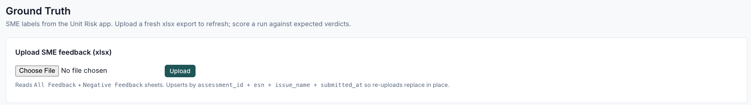

Task B — Look up the label for a cell
- In Browse labels, type any combination of ESN, Issue, Component. Leaving fields blank widens the search.
- Click Search.
The table shows every matching label with feedback direction (up / down / none), expected severity, comments, and the SME's name + date. A down label is a negative-feedback row — the LLM's answer was wrong; the corrected severity may live in the feedback_type / correctness columns rather than expected_severity. Read the comment alongside.
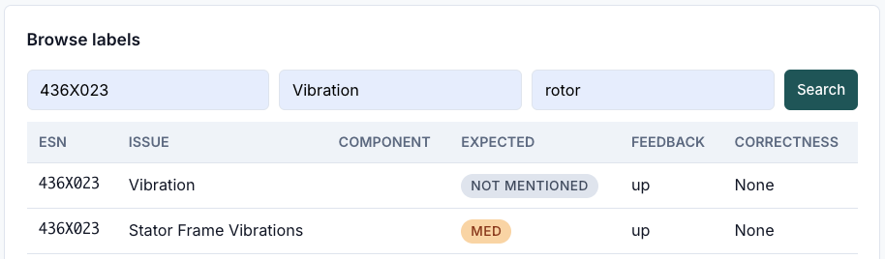

Task C — Score a finished run
- Copy any run's UUID (from Probe Runner's Recent Runs or a lab run).
- Paste it into the Score a run field.
- Click Score.
You get an iter-by-iter table showing predicted vs. expected severity, with a top-line match rate. Use this to confirm a prompt change improved correctness, not just consistency.
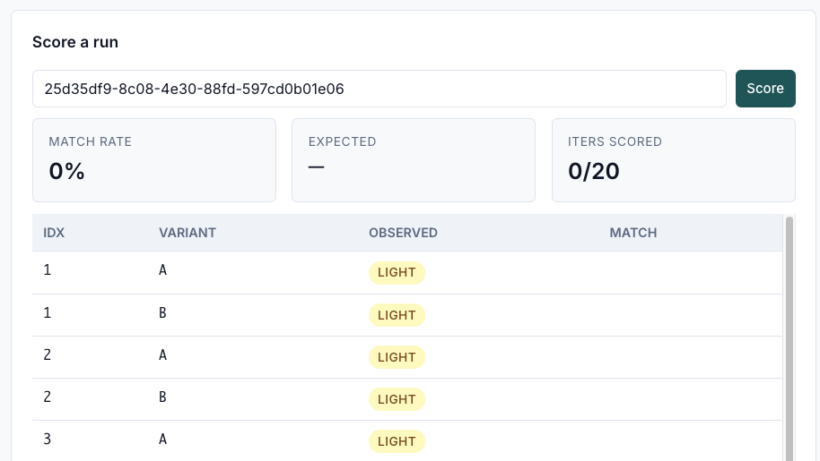

Task D — Add a manual label
If an SME tells you "for ESN X, the right answer is Light" outside of the feedback export pipeline, capture it here:
- Fill in ESN, Issue name, Component.
- Pick the Expected severity.
- Add Evidence summary and Comments (free text — write what the SME said and why).
- Click Add.
The label joins the same pool the upload populates, so future scoring picks it up automatically.
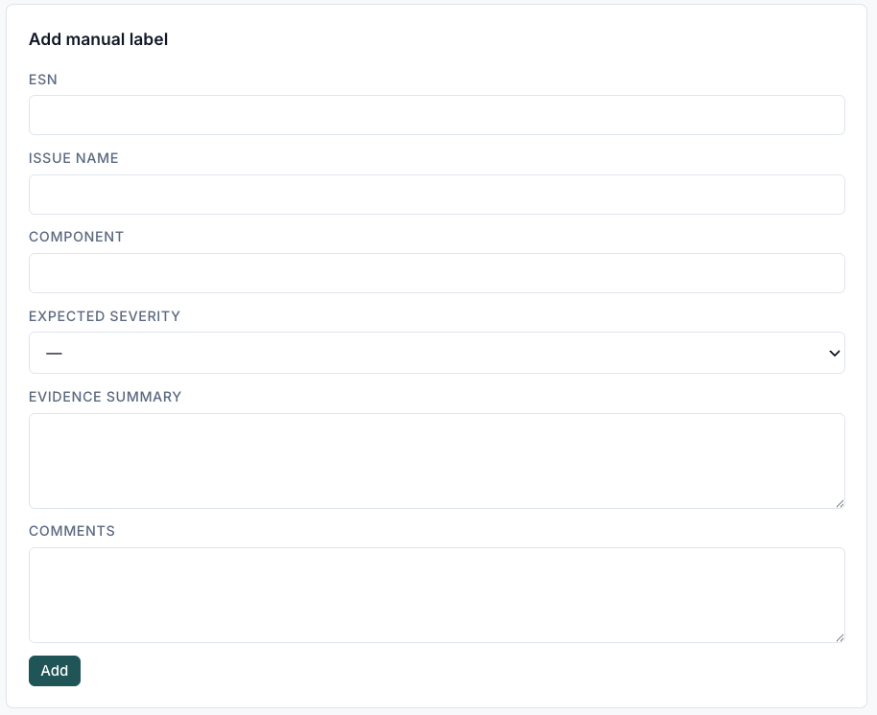

Control reference
Control | What it does
Upload SME feedback (xlsx) → Choose file / Upload | Loads a fresh feedback export. Supports .xlsx only.
Browse labels → ESN / Issue / Component filters | Free-text filters. At least one must be non-empty.
Search | Runs the filter.
Score a run → run id | The UUID of the run to score.
Score | Pulls all iters from that run and matches each against the cell's SME label.
Add manual label | Form for one-off labels. Same fields as the xlsx upload.

Reading the results
- feedback = down with correctness set → SME rejected the model's original answer; the correct verdict is in the correctness column. Scoring against expected_severity would treat the original wrong answer as truth — read the comment.
- feedback = up → SME confirmed the model's answer; expected_severity is the model's verdict and is correct.
- No label found → no SME has reviewed this cell yet. Run results cannot be scored automatically; judge by other means or request a label.

4. Retrieval Inspector

What it's for
Look at the evidence the model saw — chunk by chunk — and confirm whether retrieval was stable across iters in a run. Use this when:
- A run's verdicts varied wildly and you suspect retrieval was the culprit (vs. the LLM).
- You want to read the actual FSR / ER text the model was reasoning over.
- You're debugging a "the model is hallucinating quotes" claim.

Common tasks
Task A — Read the chunks for one iter
- Pick a run from the Pick a run dropdown.
- The left card lists every iter in that run. Click one.
- The right card shows that iter's chunks. Switch between FSR and ER subtabs.
Each chunk shows the document name, page, evidence text, and similarity score. This is the literal text the model saw in its prompt for that iter.
Task B — Check whether retrieval was stable across iters
- Pick a run.
- The Jaccard heatmap card (below the iter list) shows an N×N grid: each cell is the overlap between two iters' chunk sets.
Reading the heatmap:
- All cells dark (≈1.0) → retrieval is stable; chunk sets are identical or near-identical across iters. Any verdict drift is purely LLM stochasticity.
- Mixed colors / lighter cells → retrieval is varying. Chunk membership differs between iters; verdict differences may be partly retrieval-driven.
Switch between FSR and ER subtabs in the heatmap header to inspect each source separately.

Control reference
Control | What it does
Pick a run dropdown | Selects which run to inspect. Lists recent runs newest-first.
Iter list (left) | All iters in the chosen run. Click to load that iter's chunks on the right.
Jaccard heatmap | N×N similarity matrix across all iters. Diagonal is always 1.0 (a set's overlap with itself).
FSR / ER subtab (heatmap) | Switches which source the heatmap shows.
Chunks panel (right) | Detail of the selected iter's chunks.
FSR / ER subtab (chunks) | Switches between Field Service Reports and Engineering Reports for the selected iter.

Reading the results
- Same prompt, same chunks, different verdicts → the LLM is non-deterministic on this evidence. Either tighten the prompt or run more iters and take majority vote.
- Same prompt, different chunks per iter → retrieval is unstable. This is rare with the standard config; investigate before drawing conclusions about prompt quality.
- Chunks do not contain the evidence the model cited → the model hallucinated a quote. This is a strong signal for prompt-side gating.

5. Reports

What it's for
A library of frozen snapshots of lab runs. A Test Report captures the full state of a run — prompts, every iter, raw responses, retrieved chunks, plus the SME label match — into a single record that survives even if the source run is deleted. Use it when:
- You want to share a result with an SME or PM who isn't going to log into the app.
- You need a permanent receipt of "what the prompt produced on this cell on this date."
- You want an LLM-driven analysis of how the prompts performed against ground truth.

Common tasks
Task A — Create a Test Report
Reports are created from the Prompt Lab tab, not from this page. After a lab run completes, click Create Test Report in the Results card (see §2 Task D). The new report appears in the list here.
Task B — Browse and open reports
- Click Refresh to pull the latest list.
- The list shows: name, ESN/issue/component, created date, number of variants, number of iters, and the match rate against ground truth.
- Click any row to open it. The detail panel shows the full report inline.
Task C — Share a report
Every row has a Download action that saves the report as a single report-<esn>-<short-id>.json file. Send it to anyone — the file is self-describing and includes prompts, evidence, and verdicts.
Task D — Have an LLM diagnose the prompts
When you open a report, the detail panel includes an Analyze with LLM button. Click it to run a structured diagnosis: per-variant scoring, identified weaknesses in system vs. user prompt (with a generalization-safety note for system-prompt changes), and ranked suggestions. The analysis is persisted, so re-opening the report later shows the prior analysis without re-running. You can run multiple analyses on the same report (e.g. after the analyzer prompt is updated) and pick from a history dropdown.
Task E — Delete a report
Each row has a delete action. Deletion is permanent — the JSON snapshot is removed from the database. (The original lab run is unaffected.)

Control reference
Control | What it does
Refresh | Re-pulls the report list.
Report row → row click | Opens the detail panel.
Report row → Download | Saves the report as JSON.
Report row → Delete | Removes the report from the library.
Detail panel → Close | Collapses the detail panel without leaving the page.
Detail panel → Analyze with LLM | Runs a structured analyzer on the report.
Detail panel → Analysis history | If multiple analyses exist on the report, pick one to view.

Reading the results
- High match rate (≥ 80% on one variant, much lower on the other) → that variant is producing the right verdicts more often. Check the analysis narrative to understand why.
- Both variants high match rate → both prompts work for this cell. Pick the one with lower drift / shorter prompt / better generalization story.
- Both variants low match rate → the prompt is not the only problem. Check the retrieval (Retrieval Inspector) and the SME comment (Ground Truth) before iterating further.

Tips and conventions
- Sticky inputs. ESN / issue / component fields remember the last value you typed. Useful when probing one cell across multiple pages.
- Persona is almost always RE. Only flip to SME if you have a specific reason.
- Iter UUIDs are everywhere. Most "load this exact thing" features take an iter UUID. Copy them from the iter rows in any list.
- Reports are immutable. Once created, a report cannot be edited. Re-run the lab and create a new report instead.
- Saved variants are immutable. Re-saving with the same name creates a new version; old versions are kept forever.
- Med vs Medium. The system normalizes both spellings — either is fine in filters.

